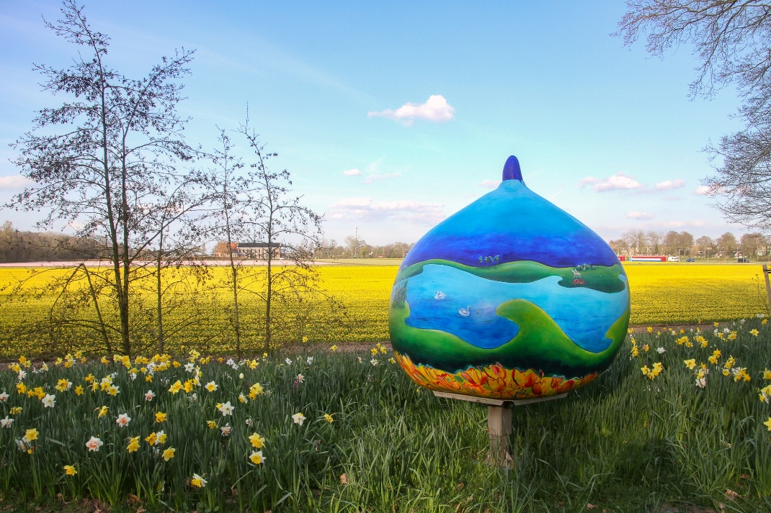

**Giant Bulbs Route**

Starting point junction 91, Heereweg 254 Lisse

Route length: approx. 28.0 km

Duration of route: approx. 2 hours

Last update: 16 May 2024

In spring, cycle past a beautiful carpet of flowers à la Mondrian: colourful bulb fields in yellow, red, orange and purple rival the green of the meadow. Monumental bulb sheds, a stretch of Dutch dune and the picturesque village centres of Noordwijk-Binnen and Lisse complete it all. Along the way, you will come across colourfully painted giant bulbs depicting the story of the Bulb Region at various places.

**Nodes**

91 • 30 • 38 • 57 • 55 • 58 • 59 • 06 • 84 • 67 • 46 • 66 • 72 • 15 • 34 • 24 • 28 • 32 • 43 • 86 • 92 • 09 • 35 • 47 • 26 • 36 • 48 • 40 • 49 • 29 • 91

**Art project**

The man-sized works of art in the shape of a tulip bulb will be painted by dozens of artists from the Bulb Region. The 80 Giant Bulbs between Leiden and Haarlem all tell their own story, related to the Bulb Region. With this beautiful art project, the Stichting Gildemeesters Bollenstreek will put the region even more on the map. The region will become attractive to visit all year round!

**More information about the route.**

<https://www.anwb.nl/fietsroutes/routes/bollenstreekroute>